**Login**

**Index**

**Search**

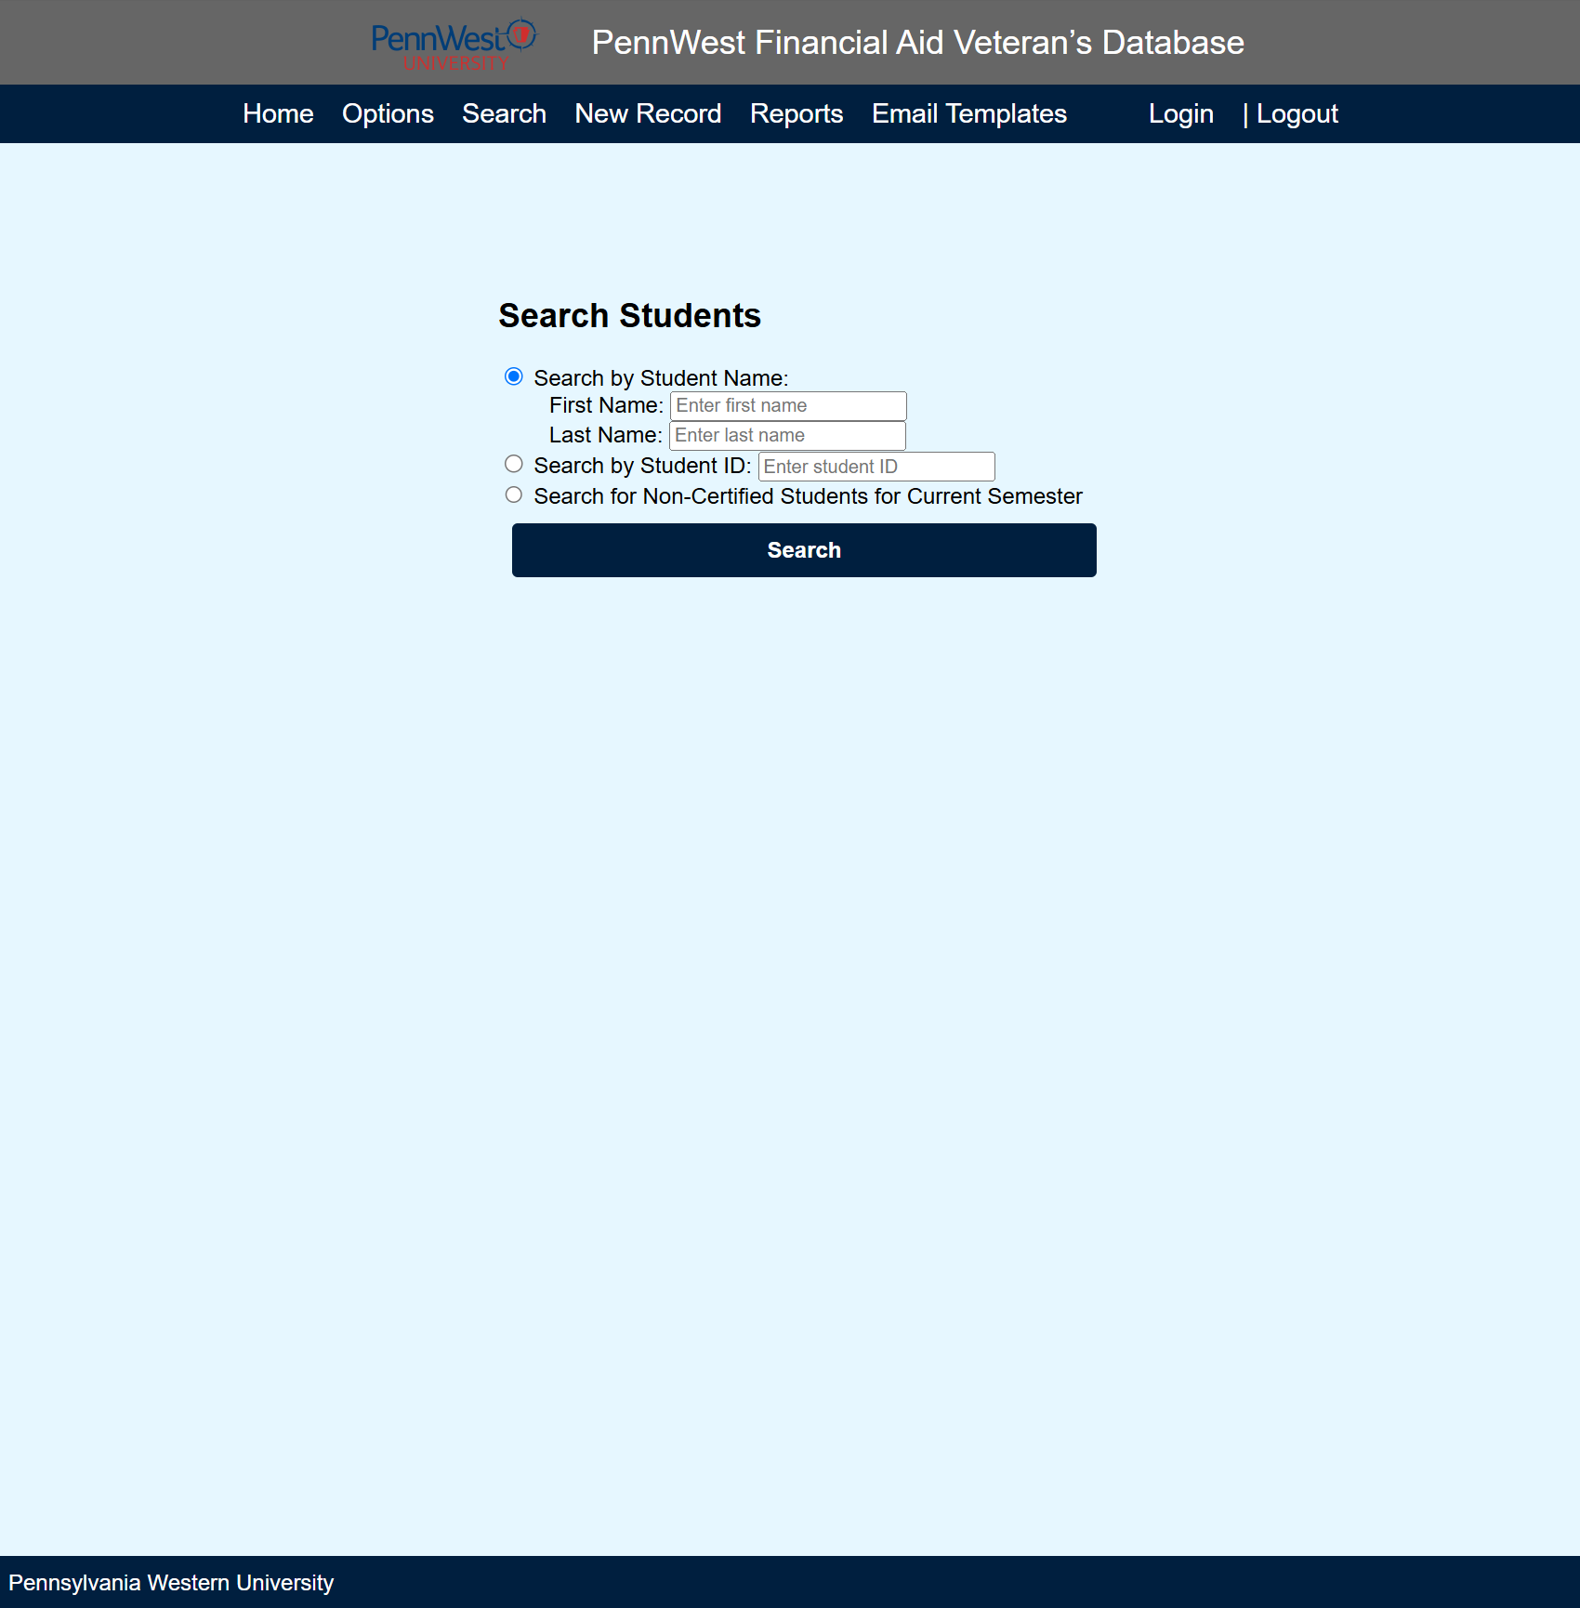

**Search Results**

**New Record**

**Student Record**

**Email**

**Report**

**Report Results**

